**专题19 书面表达**



**1.（2023年全国甲卷）**

你们学校正举办主题为“用英文讲中国故事”的征文活动。请你以一位中国历史人物为题写一篇短文投稿，内容包括：

1.人物简介及事迹；

2. 意义或启示。

1.词数 100 左右;

2.可以适当增加细节，以使行文连贯**。**

*_______________*____________________________________________________________________________________________________________________________________________________________________________________________________________________________________________________________________

**2.（2023年全国乙卷）**

请以向学校英文报投稿的方式，用英语描述学到的一项新技能的经历及从中获得的体验和感受。

注意:

1.词数100左右;

2.可以适当增加细节，以使行文连贯。写作思路:

*_______________*_____________________________________________________________________________________________________________________________________________________________________________________________________________________________________________________________________

**3.（2023年浙江卷1月）**

上周末你参加了校学生会组织的“认识我们身边的植物”活动。请为校英文报写篇报道，内容包括：

1. 活动的过程；

2. 收获与感想。

注意：

1. 写作词数应为80左右；

2. 请按如下格式在答题纸的相应位置作答。

**Getting to Know the Plants Around Us**

________________________________________________________________________________________________________________________________________________________________________________________________________________________________________________________________________________________________________________________________________________________________________________________________________________________________________________________________

**2022年全国甲卷**

你校将以六月八日世界海洋日为主题，举办英语征文比赛，请你写一篇短文投稿。

内容包括：

1. 海洋的重要性；

2. 保护海洋的倡议。

注意：1. 词数100左右；

2. 短文的题目和首句已为你写好。

________________________________________________________________________________________________________________________________________________________________________________________________________________________________________________________________________________________________________________________________________________________________________________________________________________________________________________________________________________________________________________________________________________________________________________________________________________________________________________________________________________________________________________________________________________________________

____________________________________________________________________________________________

**2022年全国乙卷**

学校英文报正在开展以Learning English Beyond the Classroom为题的讨论。请使用图表中的调查结果写一篇短文投稿，内容包括：

1. 学习活动状况描述：

2. 简单评论;

3. 你的建议。

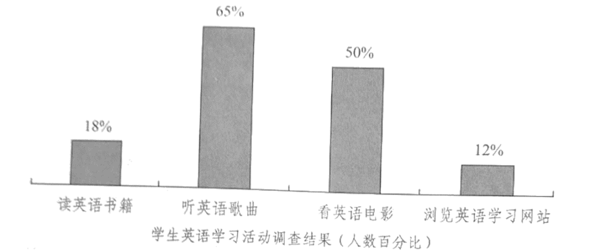

注意：

1. 词数100左右;

2. 短文的题目和首句已为你写好。

**2021年全国甲卷**

假定你是李华。你校计划举办介绍中国传统文化的主题班会，并在英文网站展示。请你写一封邮件给外国朋友Chris，向他了解哪些中国传统文化更吸引外国友人。邮件内容包括：

1.阐明写信事由；

2.征求建议；

3.表示感谢。

注意：

1. 词数100左右；

2. 可以适当增加细节，以使行文连贯。

____________________________________________________________________________________________________________________________________________________________________________________________________________________________________________________________________________________________________________________________________________________________________________________________________________________________________________________________________________________________________________________________________________________________________________________________________________________________________________________________________

**2021年全国乙卷**

你校将举办英语演讲比赛。请你以Be smart online learners为题写一篇发言稿参赛，内容包括：

1. 分析优势与不足；

2. 提出学习建议。

注意：

1. 词数100左右;

2. 题目和首句已为你写好。

**2021年天津卷**

假设你是晨光中学的李津。我市为外国友人提供生活信息的某英文网站新增了 《最美中华》栏目，请你给该栏目投稿，介绍一个国内你喜欢或去过的地方。内容包括：

(1)该地方的基本情况(如名称、地理位置等)；

(2)该地方的特色(如文化、景点等)；

(3)你对该地方的印象和感受。

注意：(1)词数不少于100；

(2)可适当加入细节，使内容充实、行文连贯。

A Beautiful Place in China

March 19, 2021

By Li Jin

________________________________________________________________________________________________________________________________________________________________________________________________________________________________________________________________________________________________________________________________________________________________________________________________________________________________________________________________________________________________________________________________________________________________________

**2021年北京卷**

假设你是红星中学高三学生李华。你和英国好友Jim原定本周末一起外出，你因故不能赴约。请你用英文给他写一封电子邮件，内容包括：

1.表达歉意并说明原因；

2.提出建议并给出理由。

注意

1.词数100左右；

2.开头和结尾已给出，不计入总词数。

Dear Jim,

___________________________________________________________________________________________________________________________________________________________________________________________________________________________________________________________________________________________________________________________________________________________________________________________________________________________________________________________________________________________________________________________________________________________________________________________________________________________________________________________________________________________________________________________________________________________________________________

Yours,

Li Hua

**2020·新课标Ⅰ**

你校正在组织英语作文比赛。请以身边值得尊敬和爱戴的人为题，写一篇短文参赛，内容包括:

1. 人物简介；

2. 尊敬和爱戴的原因。

注意:

1. 词数100左右；

2. 短文题目和首句已为你写好。

________________________________________________________________________________________________________________________________________________________________________________________________________________________________________________________________________________________________________________________________________________________________________________________________________________________________________________________________________________________________________________________________________________________________________

**2020·新课标Ⅱ**

上周末，你和同学参加了一次采摘活动。请你为班级英语角写一篇短文，介绍这次活动，内容包括:

1. 农场情况；

2. 采摘过程；

3. 个人感受

注意:

1. 词数100左右；

2. 题目已为你写好。

题目:My Weekend

________________________________________________________________________________________________________________________________________________________________________________________________________________________________________________________________________________________________________________________________________________________________________________________________________________________________________________________________________________________________________________________________________________________________________

**2020·新课标Ⅲ**

假定你shi 李华，你和同学根据英语课文改编了一个短剧。给外教Miss Evans写封邮件，请她帮忙指导。邮件内容包括:

1. 剧情简介；

2. 指导内容；

3. 商定时间地点。

注意:

1. 词数100左右;

2. 结束语已为你写好。

________________________________________________________________________________________________________________________________________________________________________________________________________________________________________________________________________________________________________________________________________________________________________________________________________________________________________________________________________________________________________________________________________________________________________

**2020·江苏卷**

请阅读下面有关中国题材纪录片(documentary)的对话，并按照要求用英语写一篇150个词左右的文章。

|  |
| --- |
| Su Hua: Hi, Li Jiang! Did you see the BBC documentary on CCTV 9 last week?  Li Jiang: You mean *Du Fu: China’s Greatest Poet*? Yes, I did. Fantastic!  Su Hua: Just think an English actor recites Chinese poems.  Li Jiang: I don’t really understand every line he recites, but I believe he truly loves the poems himself.  Su Hua: Right. It is reported that the film is well received outside China.  Li Jiang: Yeah, It’s my first time to hear Chinese stories told by an English speaker.  Su Hua: In fact, documentaries about our country are plentiful both at home and abroad. These films can help foreign friends better understand this land-Chinese literature, geography history, food...  Li Jiang: I couldn’t agree more. |

【写作内容】

1.用约30个词概括上述对话的主要内容；

2.谈谈中国题材纪录片受到外国朋友欢迎的原因(至少两点)。

【写作要求】

1.写作过程中不能直接引用原文语句；

2.作文中不能出现真实姓名和学校名称；

3.不必写标题。

【评分标准】

内容完整语言规范，语篇连贯，词数适当。

________________________________________________________________________________________________________________________________________________________________________________________________________________________________________________________________________________________________________________________________________________________________________________

____________________________________________________________________________________________________________________________________________________________________________________________________________________________________________________________________________________

**2020·天津卷**

假设你是晨光中学高三学生李津。你校于6月8日举办了成人礼活动，你的英国朋友Chris很想了解该活动。你于当晚给Chris回一封电子邮件，介绍关情况，内容包括:

(1)成人礼活动内容(成长点滴回顾、观看校友抗疫事边录像)；

(2)对活动的感受；

(3)对自己未来的展望。

注意:

(1)词数不少于100；

(2)可适当加入细节，使内容充实、行方连贯；

(3)开头已给出，不计入总词数。

参考词汇:

成人礼 the coming-of age ceremony

新冠脑炎 COVID-F9

Dear Chris,

I’m so glad to hear from you.

________________________________________________________________________________________________________________________________________________________________________________________________________________________________________________________________________________________________________________________________________________________________________________

________________________________________________________________________________________________________________________________________________________________________________________________________________________________________________________________________________________________________________________________________________________________________________

Yours,

Li Jin

**2020年北京卷**

第一节

假设你是红星中学高三学生李华。你们学校英语戏剧俱乐部外籍指导教师Jim因疫情滞留英国。复学在即，作为俱乐部负责人，你给Jim写一封电子邮件，请他推荐一名外籍指导教师，内容包括：

1. 条件及要求；

2. 表示感谢并提醒注意防护。

注意：1. 词数不少于50；

2. 开头和结尾已给出，不计入总词数。

Dear Jim,

________________________________________________________________________________________________________________________________________________________________________________________________________________________________________________________________________________________________________________________________________________________________________________

____________________________________________________________________________________________________________________________________________________________________________________________________________________________________________________________________________________

Yours,

Li Hua

**第二节**

假设你是红星中学高三（1）班班长李华。居家学习期间，你们班开展了一次以“自律”为主题的调研活动。请根据以下四幅图的先后顺序，写一篇英文稿件，给你们学校英文网站投稿，记述你在本次活动中发现问题并解决问题的过程。

注意：词数不少于60。

提示词：自律 self-discipline

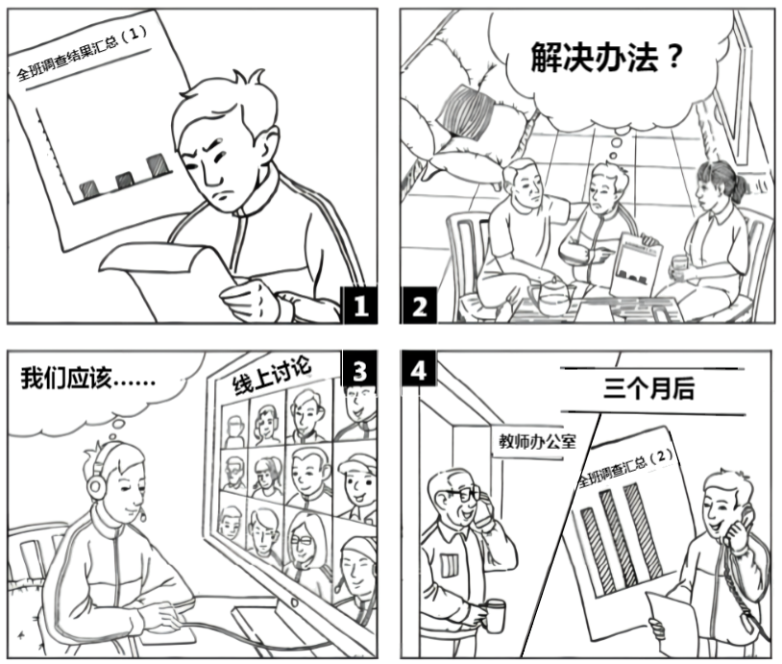

____________________________________________________________________________________________________________________________________________________________________________________________________________________________________________________________________________________

________________________________________________________________________________________________________________________________________________________________________________________________________________________________________________________________________________________________________________________________________________________________________________

**2019·全国卷I**

假定你是李华，暑假在伦敦学习，得知当地美术馆要剧版中国画展。请写一封信申请做志愿者，内容包括：

1.写信目的；

2.个人优势；

3.能做的事情。

注意:：

1.词数100左右；

2.可以适当增加细节，以使行文连贯；

3.结束语已为你写好。

____________________________________________________________________________________________________________________________________________________________________________________________________________________________________________________________________________________________________________________________________________________________________________________________________________________________________________________________________________

Looking forward to your early reply.

Yours,

Li Hua.

**2019·全国卷II**

假定你是校排球队队长李华。请写封邮件告知你的队友Chris球队近期将参加比赛，内容包括:

1.比赛信息；

2.赛前准备；

3.表达期待。

注意:

1.词数100左右；

2.可以适当增加细节，以使行文连贯。

____________________________________________________________________________________________________________________________________________________________________________________________________________________________________________________________________________________________________________________________________________________________________________________________________________________________________________________________________________________________________________________________________________________________________________________________________________________________________________________________________________________________________________________________________________________________________________________________________________________________________________________________

**2019·全国卷III**

假定你是李华，你校将举办音乐节。请写封邮件邀请你的英国朋友Allen参加，内容包括:

1.时间；

2.活动安排；

3.欢迎他表演节目。

注意:

1.词数100左右；

2.可以适当增加细节，以使行文连贯。

____________________________________________________________________________________________________________________________________________________________________________________________________________________________________________________________________________________________________________________________________________________________________________________________________________________________________________________________________________________________________________________________________________________________________

**2019·北京卷**

假设你是红星中学高三学生李华。你的英国好友Jim打算暑假期间来北京、天津和上海旅游，发来邮件询问相关信息。请你给他回复邮件，内容包括:

1.交通出行；

2.必备衣物。

注意:

1.词数不少于50；

2.开头和结尾已经给出，不计入总词数。

Dear Jim，

________________________________________________________________________________________________________________________________________________________________________________________________________________________________________________________________________________________________________________________________________________________________________________________________________________________________________________________________________________________________________________________________________________________________________________________________________________________________________________________________________________________________________________________________________________________________

Yours,

Li Hua

**2019·天津卷**

假设你是晨光中学的李津，英国友好校将派教师来你校参加为期一周的暑期交流活动。活动期间，英方教师Chris 将做一个有关西方艺术的讲座、现就讲座内容征求你校学生的意见。请根据以下提示给Chris写一封电子邮件:

（1）你喜欢的讲座话题（从音乐、美术、舞蹈中任选其一）；

（2）选择该话题的原因及关于该话题你感兴趣的内容；

（3）希望从中有何收获。

注意：

（1）词数不少于100：

（2）可适当加入细节，使内容充实、行文连贯；

（3）开头和结尾已给出、不计入总词数。

Dear Chris，

I'm Li Jim，a student at Chenguang High School.

________________________________________________________________________________________________________________________________________________________________________________________________________________________________________________________________________________________________________________________________________________________________________________________________________________________________________________________________________

Thank you for your time.

Yours，

Li Jin

**2019·北京卷**

**第一节 (15分)**

51. 假设你是红星中学高三学生李华。你的英国好友Jim打算暑假期间来北京、天津和上海旅游，发来邮件询问相关信息。请你给他回复邮件，内容包括：

1. 交通出行；

2. 必备衣物。

注意：

1. 词数不少于50；

2. 开头和结尾已经给出，不计入总词数。

*Dear Jim,*

________________________________________________________________________________________________________________________________________________________________________________________________________________________________________________________________________________________________________________________________________________________________________________

*Yours,*

*Li Hua*

**第二节**

假设你是红星中学高三学生李华。你们班上周组织了一次以“劳动最光荣”为主题社会实践活动。请根据以下四幅图的先后顺序，写一篇英文周记，记述整个过程。



注意：词数不少于60。

提示词：西瓜watermelon

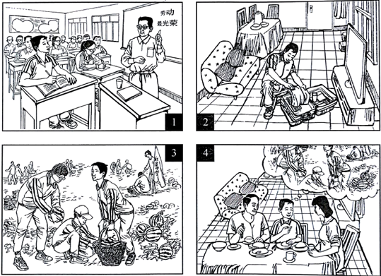

________________________________________________________________________________________________________________________________________________________________________________________________________________________________________________________________________________________________________________________________________________________________________________________________________________________________________________________________________

**2018·全国卷I**

假定你是李华，你的新西兰朋友Terry将去中国朋友家做客，发邮件向你询问有关习俗。请你回复邮件，内容包括：

1．到达时间；

2．合适的礼物；

3．餐桌礼仪。

注意：

1．词数100左右；

2．可以适当增加细节，以使行文连贯。

________________________________________________________________________________________________________________________________________________________________________________________________________________________________________________________________________________________________________________________________________________________________________________________________________________________________________________________________________________________________________________________________________________________________________________________________________________________________________________________________________________________________________________________________________________________________

**2018·全国卷II**

你受学生会委托为校宣传栏“英语天地”写一则通知，请大家观看一部英语短片*Growing Together*，内容包括：

(1)短片内容：学校的发展；

(2)放映时间、地点；

(3)欢迎对短片提出意见。

注意：

(1)词数100左右；

(2)可以适当增加细节，以使行文连贯。

____________________________________________________________________________________________________________________________________________________________________________________________________________________________________________________________________________________________________________________________________________________________________________________________________________________________________________________________________________________________________________________________________________________________________

**2018·全国卷III**

假定你是李华，你的英国朋友Peter 来信询问你校学生体育运动情况。请给他回信，内容包括：

1. 学校的体育场馆；

2. 主要的运动项目；

3. 你喜欢的项目。

注意：1. 词数100左右：

2. 可以适当增加细节，以使行文连贯。

____________________________________________________________________________________________________________________________________________________________________________________________________________________________________________________________________________________________________________________________________________________________________________________________________________________________________________________________________________________________________________________________________________________________________________________________________________________________________________________________________

**2018·天津卷**

假设你是晨光中学的机器人兴趣小组组长李津，你的美国朋友Chris就读于天津某国际学校，他曾在机器人技能竞赛中获奖。你打算邀请他加入你的团队，参加即将于7月底在天津举行的世界青少年机器人技能竞赛。请根据以下提示代表兴趣小组给他写一封电子邮件。

（1）比赛的时间、地点；

（2）邀请他的原因；

（3）训练计划将发送其邮箱，请他提出建议。

注意：（1）词数不少于100；

（2）可适当加入细节，使内容充实、行文连贯；

（3）开头和结尾已给出，不计入总词数。

参考词汇：

世界青少年机器人技能竞赛 the World Adolescent Robotics Competition

Dear Chris,

I have good news to tell you. ______________________________________________________________

________________________________________________________________________________________________________________________________________________________________________________________________________________________________________________________________________________________________________________________________________________________________________________________________________________________________________________________________________

I’m looking forward to your reply.

Yours,

Li Jin

**2018·北京卷**

**第一节**

假设你是红星中学高三学生李华，你的英国朋友Jim在给你的邮件中提到他对中国文化感兴趣，计划明年来北京上大学。他向你咨询相关信息。请给他回邮件，内容包括：

(1) 表示欢迎；

(2) 推荐他上哪所大学；

(3) 建议他做哪些准备工作。

注意：(1). 词数不少于50；

(2). 开头和结尾已给出，不计入总词数。

*Dear Jim,*

________________________________________________________________________________________________________________________________________________________________________________________________________________________________________________________________________________________________________________________________________________________________________________

________________________________________________________________________________________________________________________________________________________________________________________________________________________________________________________________________________________________________________________________________________________________________________

*Yours,*

*Li Hua*

**第二节**

57. 假设你是红星中学高三学生李华，请根据以下四幅图的先后顺序，写一篇英文周记，记述你们上周接待外国学生，带领他们体验中国茶文化的全过程。

注意：词数不少于60。

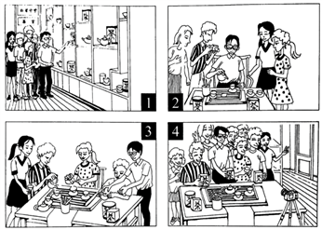

**(请务必将作文写在答题卡指定区域内)**

________________________________________________________________________________________________________________________________________________________________________________________________________________________________________________________________________________________________________________________________________________________________________________________________________________________________________________________________________________________________________________________________________________________________________________________________________________________________________________________________________________________________________________________________________________________________